WIRELESS E-NOTICE BOARD

AIM: The main aim of the project is to display user defined message on dot matrix display by using GSM technology.
Block diagram:
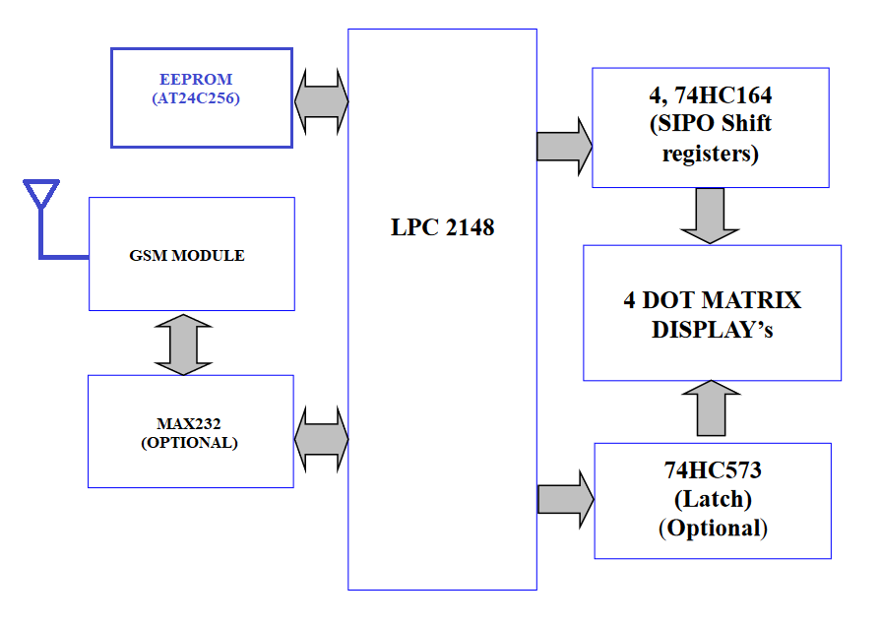
CONNECTIONS TO BE USED:
DOT MATRIX DISPLAY:
Dot matrix display connections are established with the help of two different IC’S. Those are 74HC164 (8-bit serial-in, parallel-out shift register) & 74HC573 (Octal D-type transparent latch).
74HC164: (below mention connections are for 4 dot matrix displays)
FOR DISPLAY1:
DSA (74HC164) - P0.8
CP (74HC164) - P0.9

Q0 (74HC164) - COL1 (DOT MATRIX DISPLAY)
Q1 (74HC164) - COL2 (DOT MATRIX DISPLAY)
Q2 (74HC164) - COL3 (DOT MATRIX DISPLAY)
Q3 (74HC164) - COL4 (DOT MATRIX DISPLAY)
Q4 (74HC164) - COL5 (DOT MATRIX DISPLAY)
Q5 (74HC164) - COL6 (DOT MATRIX DISPLAY)
Q6 (74HC164) - COL7 (DOT MATRIX DISPLAY)
Q7 (74HC164) - COL8 (DOT MATRIX DISPLAY)

Note: Dot matrix display to 74HC164 connections are fixed on the board

FOR DISPLAY2:
DSA (74HC164) - P0.10
CP (74HC164) - P0.11

Q0 (74HC164) - COL1 (DOT MATRIX DISPLAY)
Q1 (74HC164) - COL2 (DOT MATRIX DISPLAY)
Q2 (74HC164) - COL3 (DOT MATRIX DISPLAY)
Q3 (74HC164) - COL4 (DOT MATRIX DISPLAY)
Q4 (74HC164) - COL5 (DOT MATRIX DISPLAY)
Q5 (74HC164) - COL6 (DOT MATRIX DISPLAY)
Q6 (74HC164) - COL7 (DOT MATRIX DISPLAY)
Q7 (74HC164) - COL8 (DOT MATRIX DISPLAY)

Note: Dot matrix display to 74HC164 connections are fixed on the board

FOR DISPLAY3:
DSA (74HC164) - P0.12
CP (74HC164) - P0.13

Q0 (74HC164) - COL1 (DOT MATRIX DISPLAY)
Q1 (74HC164) - COL2 (DOT MATRIX DISPLAY)
Q2 (74HC164) - COL3 (DOT MATRIX DISPLAY)
Q3 (74HC164) - COL4 (DOT MATRIX DISPLAY)
Q4 (74HC164) - COL5 (DOT MATRIX DISPLAY)
Q5 (74HC164) - COL6 (DOT MATRIX DISPLAY)
Q6 (74HC164) - COL7 (DOT MATRIX DISPLAY)
Q7 (74HC164) - COL8 (DOT MATRIX DISPLAY)

Note: Dot matrix display to 74HC164 connections are fixed on the board

FOR DISPLAY4:
DSA (74HC164) - P0.14
CP (74HC164) - P0.15

Q0 (74HC164) - COL1 (DOT MATRIX DISPLAY)
Q1 (74HC164) - COL2 (DOT MATRIX DISPLAY)
Q2 (74HC164) - COL3 (DOT MATRIX DISPLAY)
Q3 (74HC164) - COL4 (DOT MATRIX DISPLAY)
Q4 (74HC164) - COL5 (DOT MATRIX DISPLAY)
Q5 (74HC164) - COL6 (DOT MATRIX DISPLAY)
Q6 (74HC164) - COL7 (DOT MATRIX DISPLAY)
Q7 (74HC164) - COL8 (DOT MATRIX DISPLAY)

Note: Dot matrix display to 74HC164 connections are fixed on the board

For data input user has to use 0-7 pins on the dot matrix board. Check the dot matrix board for 0-7 pins. For better understanding refer the below mentioned details.
74HC164_1 - 0 - DSA
1 - CP
74HC164_2 - 2 - DSA
3 - CP
74HC164_3 - 4 - DSA
5 - CP
74HC164_4 - 6 - DSA
7 – CP
74HC573:
D0 (74HC573) - P0.0
D1 (74HC573) - P0.1
D2 (74HC573) - P0.2
D3 (74HC573) - P0.3
D4 (74HC573) - P0.4
D5 (74HC573) - P0.5
D6 (74HC573) - P0.6
D7 (74HC573) - P0.7

Q0 (74HC573) - ROW8 (DOT MATRIX DISPLAY)
Q1 (74HC573) - ROW7 (DOT MATRIX DISPLAY)
Q2 (74HC573) - ROW6 (DOT MATRIX DISPLAY)
Q3 (74HC573) - ROW5 (DOT MATRIX DISPLAY)
Q4 (74HC573) - ROW4 (DOT MATRIX DISPLAY)
Q5 (74HC573) - ROW3 (DOT MATRIX DISPLAY)
Q6 (74HC573) - ROW2 (DOT MATRIX DISPLAY)
Q7 (74HC573) - ROW1 (DOT MATRIX DISPLAY)

Note: Dot matrix display to 74HC573 connections are fixed on the board
Based on the project requirement, need to change the port pin connections of the DOT matrix board.
REQUIREMENTS:
HARDWRAE REQUIREMENTS:
- LPC2148
- FOUR 8X8 DOT MATRIX DISPLAY’S
- 74HC573 (D-type transparent latches)
- 74HCT164 (8-bit serial-in/parallel-out)
- AT24C256
- MAX232 (Optional)
- M660A (GSM MODULE)
- USB to UART Converter
SOFTWARE REQUIREMENTS:
- EMBEDDED C – PROGRAMMING
- KEIL-C COMPILER
- FLASH MAGIC
NOTE: If dot matrix led interfacing is not done, same project we can complete with the help of LCD interface also. After DOT MATRIX LED interface done, Replace LCD display functions with DOT MATRIX LED display functions.
Steps to be followed to complete your project:
- Create New Folder in your server, save that folder with your project name.
- Individually can check each and every module.
- First write one simple program to display one character on the single dot matrix led (Already sample code was uploaded in LMS card. So, download and utilise that code)
- Then develop a program to display four-character string on the four-dot matrix Led’s
Example: HELP
- Then prepare code for string scrolling on the four-dot matrix Led’s (which has to display scrolling more than 10 characters string)
Example: PROJECT SUCUSSFULLY COMPLETED
- Next write n bytes into EEPROM and read that n number of bytes from EEPROM and display on DOT MATRIX LED.
Note: Use BYTE WRITE and BYTE READ functions or PAGE WRITE and PAGE READ functions
- Next check UART peripheral by transmitting character constant, string constant and receive string constant using UART logic (Note: use UART interrupt concept). If required use DOT Matrix display for checking purpose.
- Next connect gsm module to PC and check the gsm module working condition with the help of below mentioned AT commands.
AT
ATE0
AT+CMGF=1
AT+CNMI=2,1,0,0,0
AT+CMGD=1
AT+CMGR=1
AT+CMGS=”Mobile Number” then enter
Gsm will give the reply like ‘>’ then you have to type the message content and press ctrl+z from the keyboard to send the SMS. And send one message from your mobile and check what is the response given by the GSM module. The above-mentioned process you have to do from the hyper terminal application which is available in windows XP.
Note: for more details about AT commands refer the GSM module AT commands manual
- Next Check the GSM module working condition by developing gsm_init() function, receive_sms() function and send_sms() function. Display step by step process equivalent result on DOT Matrix display while defining these function definitions.
Note: GSM interfacing program has to develop with the help of UART interrupts only.
- If above steps are completed, create new file with projectmain.c add all peripheral definition files and write below steps in projectmain.c file
- Initialize all necessary peripherals
- In continuous loop, read the updated string which is saved in the EEPROM and scroll that string on Dot Matrix LED until unless it receives a new string. Once new message is received, it is terminating the do while process and it is reading the new message. if the message is received from one predefined mobile number, then it is reading the message content. If the message content is in secured format, then it is going to read the message content by eliminating the security key and update this new message into EEPROM. If the message is not receiving from the predefined mobile number, then one alert message sent to the predefined mobile number that from which number that message received. If the Message content is not having the proper security key, then feedback message sent back to the user. After updating message into EEPROM, delete the first message and it is again entering into do while loop.
- If you’re getting this output then your project is completed.
****************************** ALL THE BEST ******************************

